Lab 9

Lottery Winners and Multiple Thread

This lab assignment you will write a JavaFx program to practice the multiple thread in Java. There are pick up six number for the lottery winners. The numbers for each pick are the random number between 0 to 9. Firstly, the random numbers will be running on each pick as shown in below figure:

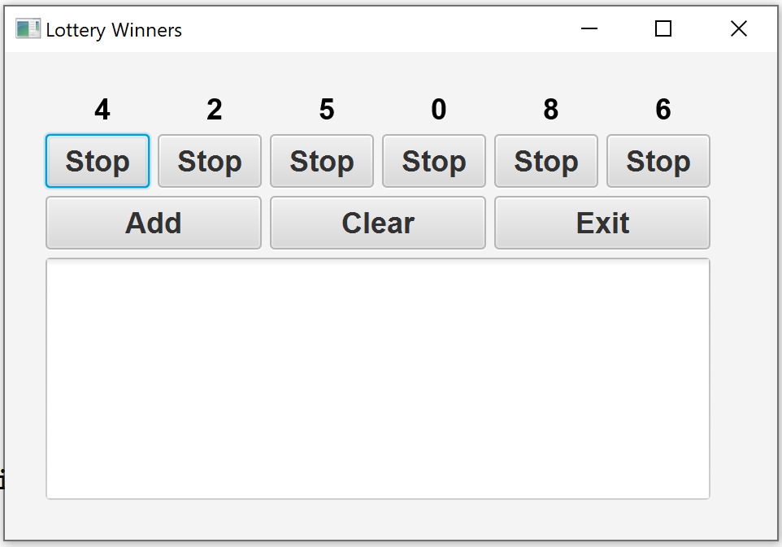

User can click Stop buttons that respect to each random number. For example, if user want to pick 2 numbers, only click the 2 Stop buttons under the numbers. The pick 2 numbers will be stopped, and user can click button Add to add the winning number into the area text as shown in the below figures:

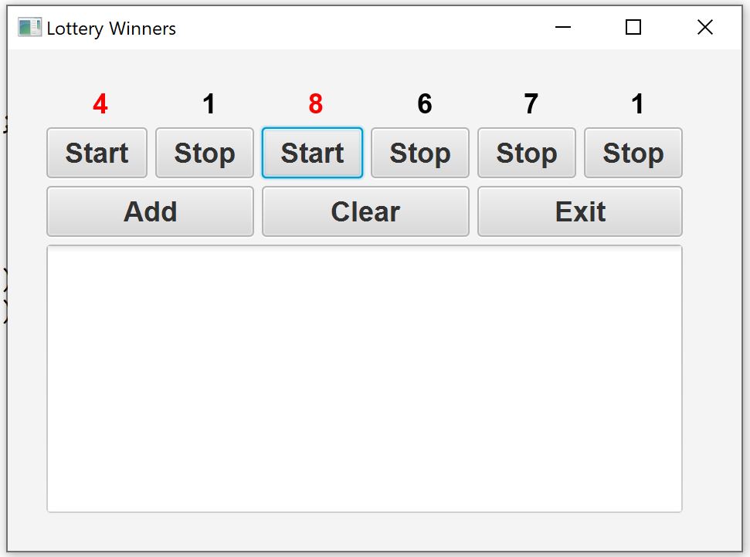

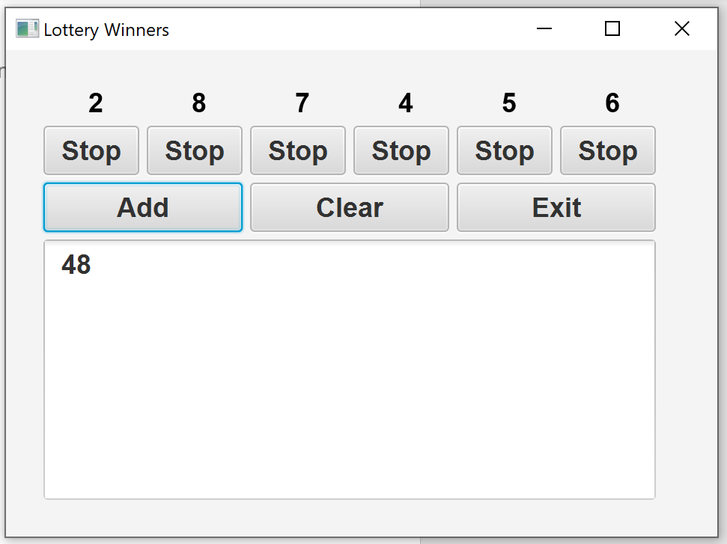

User can click Clear buttons to clear all the lottery winning numbers in area text as shown in the following figures:

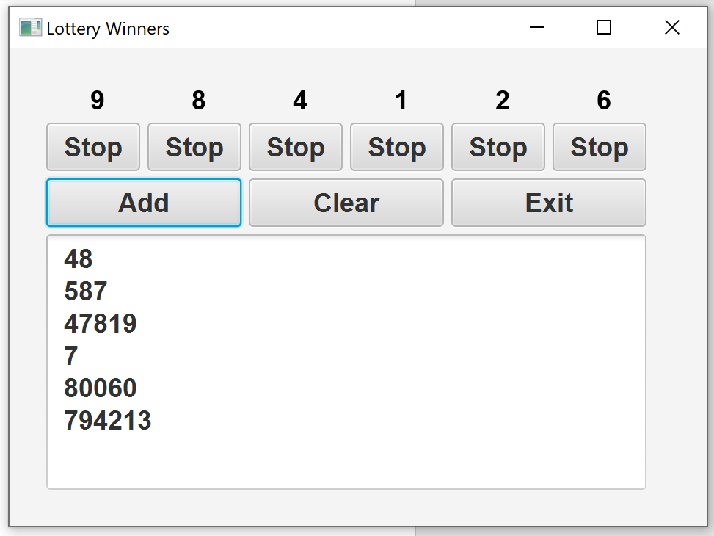

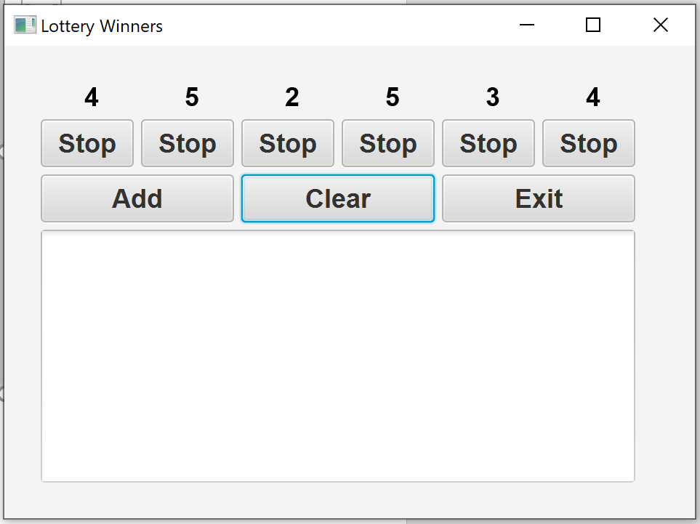

And clicks Exit Button to exit the program.

All classes should be part of a package **lottery**. You can start doing this lab by applying the initial code in FlashText.java

# Submission

After completing this lab, zip up all the classes in the **lottery** package and name of the zip file COP3809-LAB9-SYY-XXXX.zip ( YY = 01, 02, or 03 XXXX = Student ID) submit on Canvas.